Facilitation Notes for DRR Sector
The breakout Session started on second day of the workshop, before the breakout; the Risk Assessment and Risk Management were presented, after the presentation and short discussion, participants choose groups and I have been appointed as facilitator in DRR group in which discussion turn around the analysis of the climate risks and participants identify and complete climate risk currently and, in the future.
The Climate Risks identified are: Floods, drought, Heat waves, spells, strong winds and storms, disruptions of start and end of season
Their indicated also the risk causes, impacts, significant consequences and some mitigation and management and ranking have been conducted.
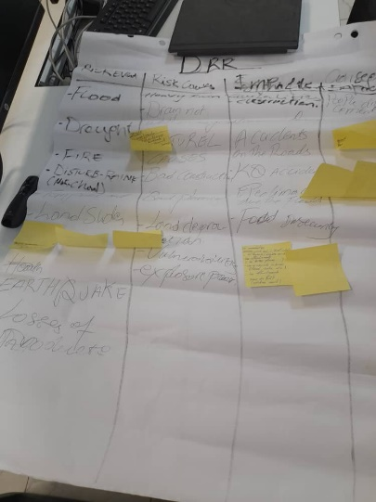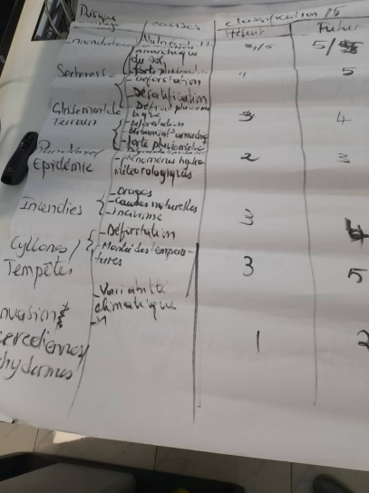
The participants also identified climate products and services provided by RCCs and National Met, timeframe, format and targeted group, thereafter the identified key climate products and services their need which will help to cope with their needs in terms of climate information.
The needed products and services are: Impact based Forecast, Outlooks, Watches, Warnings as well as Alerts.
Participants pointed out that the barrier in the provision of effective climate services is the lack of effective user and climate service provider interaction and wished that the UIP could be one way to break that barrier.
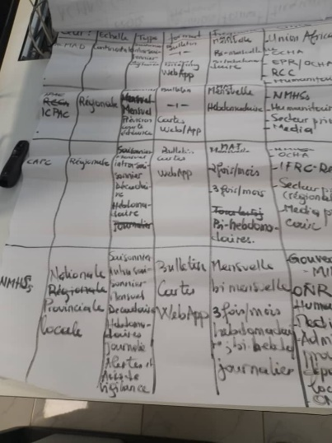
List of activities to strengthen the DRR UIP were discussed and approved by the participants and which climate information is needed to achieve those activities. The main activities identified are: Risk assessments, raise awareness on hazards, risks and mitigation measures, Establishment of MHEWS, Update of emergency preparedness and responses measures, Meteorological assistance for post disaster needs assessments, Meteorological assistance for early response and rehabilitation, share watches, outlooks, warnings and alerts, Train DRR experts on interpretation and use of climate services, Monitor and evaluate activities above.

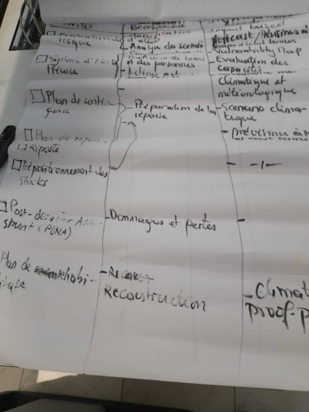

The Third Day of the breakout sessions was dedicated to elaborate and adopt the Rules of Procedures of the DRR UIP.
Participants discussed about the objectives and adopted them which are: brokering knowledge and harmonization of methodologies and products, sharing information/exchanges, raise awareness, capacity building, planification, preparedness and response plan, resources mobilization.

Participants proposed also some activities to be undertaken by UIP which are: Risk assessment, Establishment of early warning systems, updating of contingency plans, Updating of response plans, Organization of the response, Support to post-disaster inventories, Implementation of rehabilitation plans.

The climate parameters and actionable indicators which are cause of the risk was identified such as: downscaled high-resolution forecast and scenarios, advisories for specific sectors, skilful forecast (forecast verification and uncertainties), simplied products, products in comprehensive languages, advanced tailored products and real time services dissemination.

After discussion the participants come up with the proposed Rules and Procedures which are:

The Chair will be AUC, with 2years renewables ones while ACMAD will be lead the secretariat with rotation possible.
The participants proposed twice a year to convene the meeting back-to-back with African Working Group of Disaster Risk Reduction, if necessary, the chair could convene extraordinary meeting.
About the evaluation/review and monitoring, the participants agreed that the Evaluation and monitoring will be based on performance indicators clearly defined with baseline.
Participants mentioned also that a standard capacity building plan should be elaborate the secretariat and approved by the chair, so it can guide the training activity.

At the End participants discussed about the source of funds to support DRR UIP activities, which is critical to achieve and success the activities. Participants listed some donors such us: EU Projets, PNUD, UNDRR, WB, AfDB
Fonds Vert Climat, AUC (NEPAD), AGRA, WMO (CREWS), as well as others DONORS.

Godefroid NSHIMIRIMANA
UIP – DRR Facilitator

